1. Marriage Entry

Table of Contents
Marriage Entry 2
The “Parties” tab 3
The “Officiant” tab 5
The “Confidential” tab 7
The “Notes” tab 10

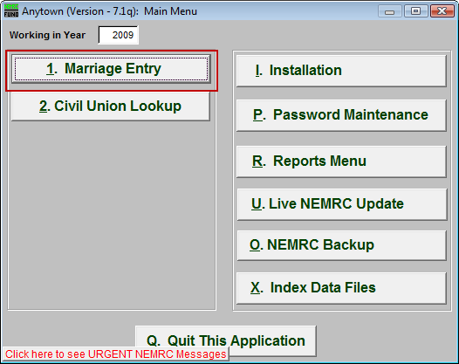
Click on “1. Marriage Entry” from the Main Menu and the following window will appear:

Marriage Entry

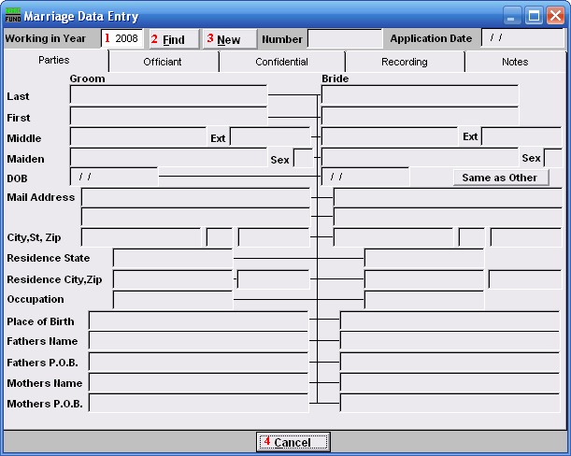
- Working in Year: Enter the Year that you wish to work in. For a new Entry, use the Current Year.

- Find: Click this button and select the Entry from the table.

- New: Click this button to create a new Marriage Entry.

- Cancel: Click “Cancel” to cancel and return to the previous screen.

The “Parties” tab

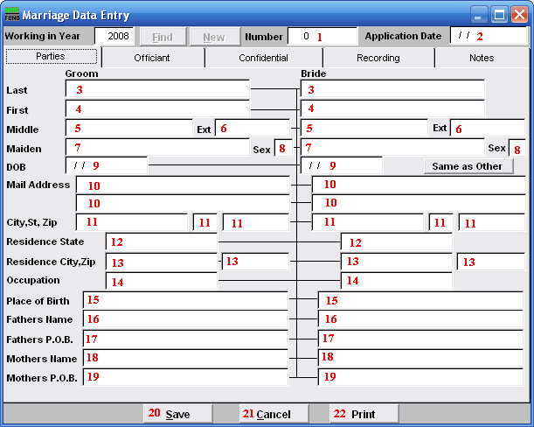
- Number: This must be a unique number. The recommendation is to use the preprinted number in the upper right hand corner of the document provided by the state of Vermont.

- Application Date: Enter the date the application was submitted.

- Last: Enter the Groom’s/Bride’s Last name.

- First: Enter the Groom’s/Bride’s First name.

- Middle: Enter the Groom’s/Bride’s Middle name.

- Ext: Enter the Groom’s/Bride’s extended name (Sr., Jr., 3rd).

- Maiden: Enter the Groom’s/Bride’s Maiden name.

- Sex: Enter the Groom’s/Bride’s Sex.

- DOB: Enter the Groom’s/Bride’s Date of Birth in MM/DD/YYYY format.

- Mail Address: Enter the Groom’s/Bride’s Mailing Address.

- City, St, Zip: Enter the Groom’s/Bride’s City, State and Zip code.

- Residence State: Enter the Groom’s/Bride’s Residence State.

- Residence City, Zip: Enter the Groom’s/Bride’s Residence City and Zip code.

- Occupation: Enter the Groom’s/Bride’s Occupation.

- Place of Birth: Enter the Groom’s/Bride’s Place of Birth.

- Fathers Name: Enter the Groom’s/Bride’s Father’s full name.

- Fathers P.O.B.: Enter the Groom’s/Bride’s Father’s Place of Birth.

- Mothers Name: Enter the Groom’s/Bride’s Mother’s full name.

- Mothers P.O.B.: Enter the Groom’s/Bride’s Mother’s Place of Birth.

- Save: Click this button to save on this computer. Refer to GENERAL FILE for more information.

- Cancel: Click “Cancel” to cancel and return to the previous screen.

- Print: Click this button to print. Refer to GENERAL PRINTING for more information.

The “Officiant” tab

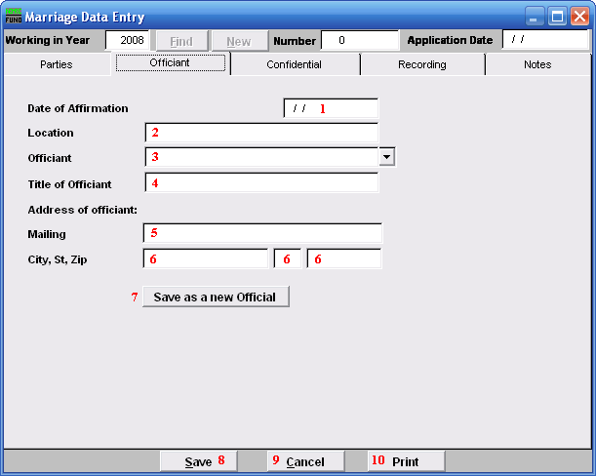
- Date of Affirmation: Enter the date the Marriage took place, in MM/DD/YYYY format.

- Location: Enter the Location the Marriage took place.

- Officiant: Enter the name of the Officiant that performed the service.

- Title of Officiant: Enter the Title of the Officiant.

- Mailing: Enter the Mailing address of the Officiant.

- City, St, Zip: Enter the City, State and Zip code of the Officiant.

- Save as a new Official: Click here if you want to save this Officiant’s information as a new Official. This list is maintained in “I. Installation” off the Main Menu under the “Officials” tab.

- Save: Click this button to save on this computer. Refer to GENERAL FILE for more information.

- Cancel: Click “Cancel” to cancel and return to the previous screen.

- Print: Click this button to print. Refer to GENERAL PRINTING for more information.

The “Confidential” tab

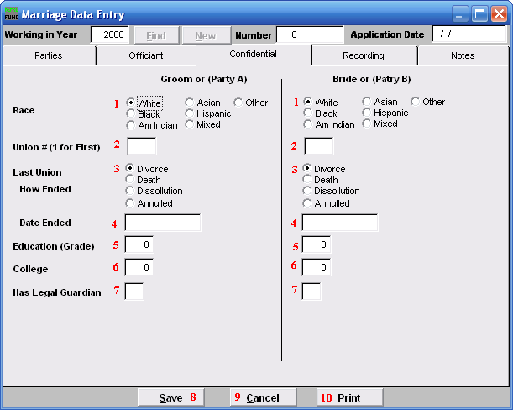
- Race: Click on the circle next to the Race of the Groom (Party A/Bride (Party B).

- Union #(1 for First): Enter the # this makes for the Groom’s (Party A’s)/Bride’s (Party B’s) Union.

- Last Union How Ended: Click on the circle next to the reason for how the last Union ended.

- Date Ended: Enter the date the last Union Ended.

- Education (Grade): Enter the number of years the Groom (Party A)/Bride (Party B) entered in Grade school.

- College: Enter the number of years the Groom (Party A)/ Bride (Party B) entered in College.

- Has Legal Guardian: Enter “Y” for Yes or “N” for No if the Groom (Party A)/Bride (Party B) has a Legal Guardian.

- Save: Click this button to save on this computer. Refer to GENERAL FILE for more information.

- Cancel: Click “Cancel” to cancel and return to the previous screen.

- Print: Click this button to print. Refer to GENERAL PRINTING for more information.

The “Recording” tab

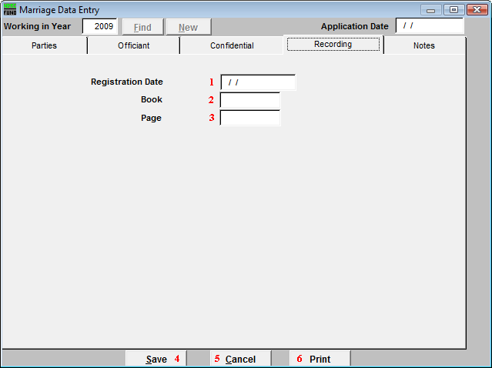
- Registration Date: Enter the date that this Marriage was registered.

- Book: Enter the Book this information will be recorded in.

- Page: Enter the Page number this information will found on.

- Save: Click this button to save on this computer. Refer to GENERAL FILE for more information.

- Cancel: Click “Cancel” to cancel and return to the previous screen.

- Print: Click this button to print. Refer to GENERAL PRINTING for more information.

The “Notes” tab

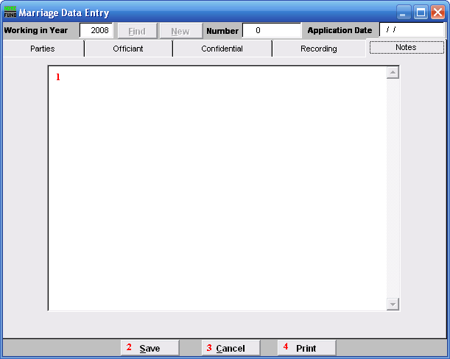
- This is a User defined field.

- Save: Click this button to save the information you have entered and return to the Marriage Data Entry screen.

- Cancel: Click “Cancel” to cancel and return to the previous screen.

- Print: Click this button to print. Refer to GENERAL PRINTING for more information.

